**Bone is a Living Tissue**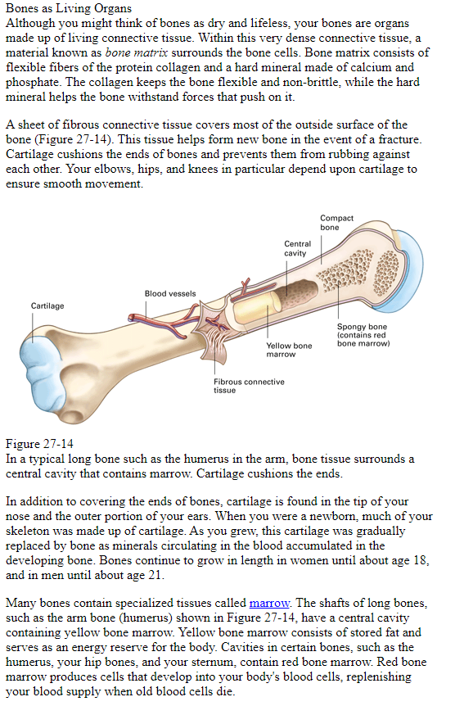

* Read the information to the left
* **I**n your spiral, record the answers to the following:

Describe bone tissue- include what the bone matrix consists of and how each contributes to bone strength.

What is the difference between yellow and red marrow- compare the structure and function, not just color?

What is the purpose of the cartilage at the end of a bone?

**Anatomy of the Skeleton.**

* **Read the information on this page and look at the diagram on the next page**
* **Complete notes**

In your spiral, record the answers to the following:

* Define/describe cartilage
* What are cartilage discs (describe the structure and function of these)?

**(Deduce the meanings from the diagram)**

* What is the appendicular skeleton?
* What is the axial skeleton?

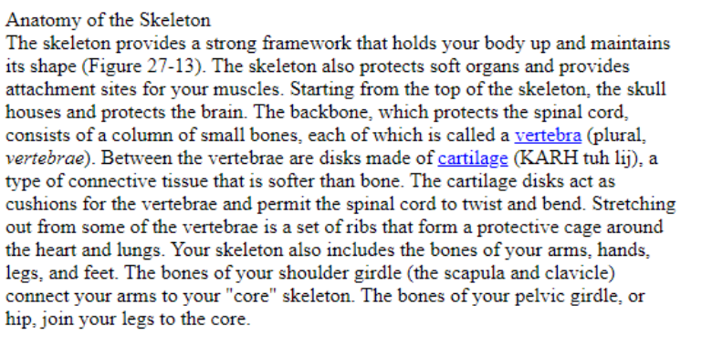

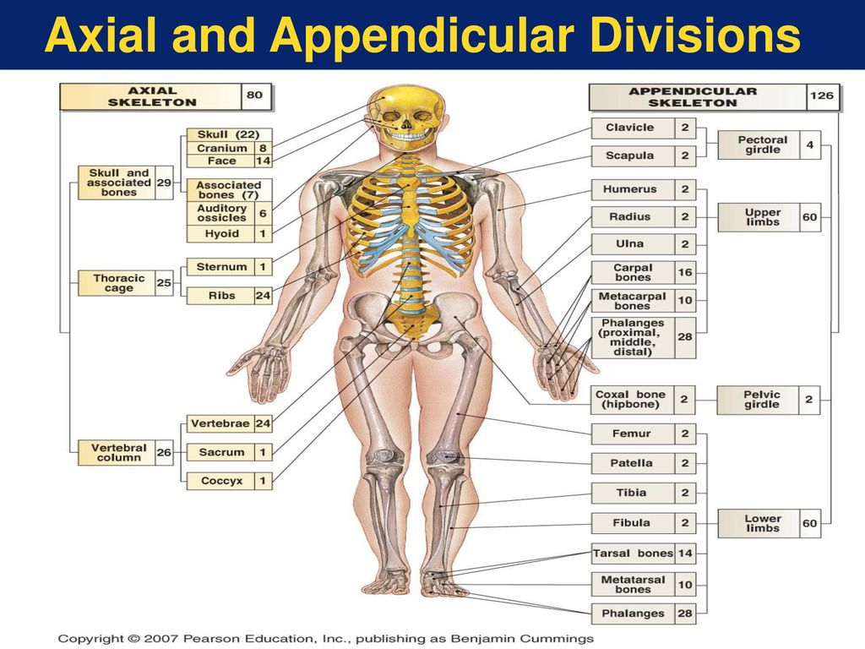

**Structure of a Skeletal Joint**

* **Read the information below**
* **Complete notes**

In your spiral, record the answers to the following:

* Define and describe (own words or example) the following:

Joint ligament movable joint

* Describe an immovable joint and the reason these exist.
* What are the main functions of the skeletal system? Can you link a specific structure to each function?

